IT24102383

Imani H.A.I

Lab 05

Exercise

01)

02)



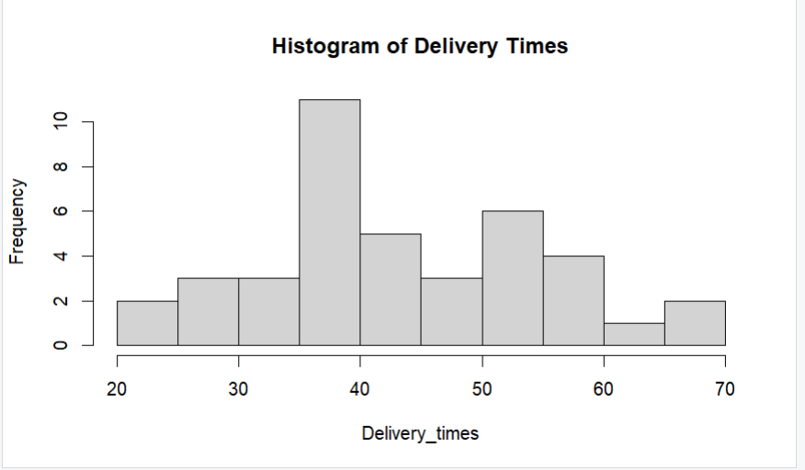

03)

The distribution of delivery times is approximately symmetric and unimodel, with the peak around 35-40 minutes. It is not strogly skewed.

04)

